**GST HEADLINES**

**September 7, 2016**

**Govt. Begins Discussions for Creation of Secretariat to Assist GST Council**

***[Source : The Economic Times]***

**AP Cabinet Gives Nod for GST Bill**

***[Source : Business Line]***

# States Can't Escape Adoption of GST

***[Source : Business Standard]***

# 

# AP Cabinet gives nod for GST Bill

**HYDERABAD, SEPT 6:**

The Andhra Pradesh Cabinet today approved the Goods and Services Tax Bill during a meeting held at Vijayawada and plans to take it up at the forthcoming assembly session for its approval.

The Cabinet meeting chaired by Chief Minister N Chandrababu Naidu discussed various implications of the Bill on the State and finally put its stamp of approval.

The AP state legislative assembly has been convened on August 8 to take up the Bill for passage. The brief session, details of which will be finalised at the Business Advisory Committee of the Assembly in September 8, will take up the Constitution Amendment Bill on Goods and Services Tax. The GST amendment has already secured approvals from several states.

The State was initially planning to hold the session at the new capital city of Amaravati. However, with infrastructure yet to be fully ready to host the Assembly session, it was decided to convene it Hyderabad. The Government had to decide to hold the meet in September itself as the Centre had called upon the State to approve the amendment so that it could be taken at the earliest in Parliament for approval.

If the plans go as per Government decision, this could be the last assembly meet of AP in Hyderabad. From now on it is proposed to shift the venue to Amaravati.

Telangana had recently unanimously approved the GST Bill.

# States can't escape adoption of GST

## States can only opt for another structure, but experts say that might not be sustainable, once the Constitution amendment Bill becomes a law

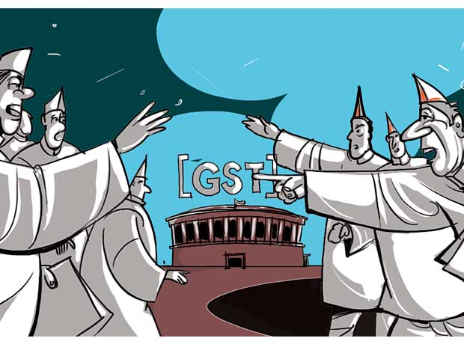

States opposing the goods and services tax (GST), such as Tamil Nadu, would not be able to avoid the indirect tax regime after the Constitution amendment Bill becomes law.  
  
The states would, however, be able to adopt a GST structure than is different from the one recommended by the proposed GST Council. The recommendations of the council would not be binding on the states. It should be noted that GST is targeted to be rolled out from April one, 2017 and for the purpose the Centre would have to pass the Central GST and Integrated GST Bills and the states their respective pieces of GST legislation.

"The Constitution applies to the entire country, so each state has to impose GST once the new tax system is introduced," constitutional expert Subhash Kashyap said.

There could only be GST on sale of goods and services from the date the new tax regime is rolled out, Satya Poddar of EY said.

There were worries that if some states opt out of GST, as had happened during implementation of state-level value added tax (VAT) initially, the GST chain could be broken. The fears arose because AIADMK had walked out before voting on the Constitution amendment Bill began, both in the Rajya Sabha and the Lok Sabha. The party had wanted some changes in the Bill, such as imposition of four per cent additional tax in inter-state trade and transferring the collected money from that tax to the state from where the goods originated.

More than half of the states have ratified the Constitution amendment Bill and the President's assent is expected soon.

The Bill says the GST Council would make recommendations to the Centre and the states on issues such as the taxes, cess and surcharges that might be subsumed in the goods and services tax rate. Parliament and Assemblies have the right to accept those recommendations in their GST Bills.  
  
Poddar said Tamil Nadu has the option to continue with the existing VAT system after renaming it GST.  
  
He said the input tax credit chain will not be broken even if Tamil Nadu chooses to do so.  
  
He explained that goods or services coming from Tamil Nadu would attract integrated GST - total of central GST and state GST - which will be collected by the Centre and the state's portion will be returned, depending on certain factors. The modalities of the share would be decided by the GST Council. Whether in such a system Tamil Nadu will be given a share of IGST or not has still not been worked out. However, Tamil Nadu can still impose VAT. But that would be additional tax over IGST and hence unviable, Poddar said.

Another option for an anti-GST state could be that it might persuade the Centre to cut IGST by half and then impose the existing tax structure on it, he said.

A senior finance ministry official said states not rolling out GST would lose revenue. This would also lead to the chain being broken in inter-state movement of goods and services, he said.  
  
State losing revenue this way will not be able to ask the Centre for compensation. The Centre is to compensate states for revenue losses for the first five years after GST if the states' revenues come down under the new tax regime.

The Constitution amendment Bill also gives a transition period of one year to the states to implement any provision of the GST law. However, intention of that provision is to avoid overlapping of existing provisions and the new ones under GST.

*Disclaimer : The news in the GST Corner is purely according to the information available in public domain and does not necessarily reflect the views of ICSI. Any person wishing to act on the basis of this document should do so only after cross checking with the original source.*