GST HEADLINES
September 6, 2016

GST Jolt Likely for Textile Industry, May be Taxed at Higher 12% Rate

GST Impact: Here’s why Pharma Companies must Remodel their Supply Chain Structure

[Source : The Financial Express]

GST jolt likely for textile industry, may be taxed at higher 12% rate

The government should consider alternative options like additional incentive schemes to protect the future of this employment-intensive sector
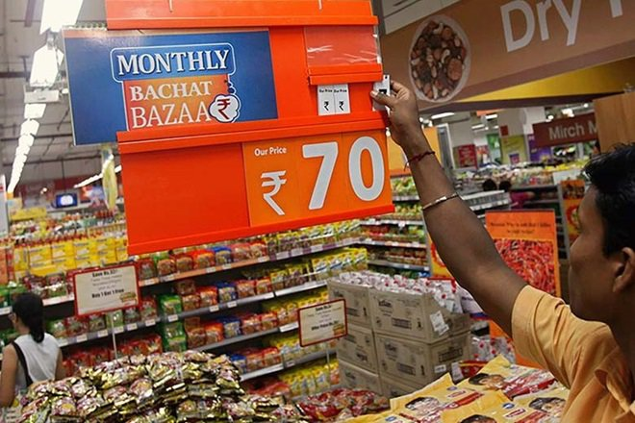

On a positive side, GST could be a timely solution by bringing uniformity and a level-playing field for textile players in all segments of the industry. (Reuters)

India’s textile industry is not only several centuries old, but has also been one of the largest contributors to the country’s exports (around 11%) and provided employment to millions.
Indirect taxes, being transaction-based, play an important role in the growth of any industry. The government has so far incentivised the textile industry through various optional exemption and incentive schemes, lower tax rate and the latest being the R6,000-crore textile booster package in June this year, which has increased the duty drawback significantly.
At present, we are on the verge of witnessing the implementation of the most awaited indirect tax reform in India, the GST, expected to be a growth stimulator. But whether this growth stimulator will support the booming textile industry in India or will it take it to a new low?
Some positives to begin with…
On a positive side, GST could be a timely solution by bringing uniformity and a level-playing field for textile players in all segments of the industry. The industry is plagued with several issues including classification disputes (fabric versus garment), differential taxation of cotton and man-made fibre, higher rate for composite mills than power looms, and so on.
Considering the textile industry is tilted towards domestic market—with the industry coming under the GST net—domestic textile players would be able to take full credit of input tax as their sales would be liable to GST. This will reduce the cost of capital investment and encourage domestic textile players. The new tax regime should positively influence exporters, as exports would be zero-rated and input tax credit would be fully available to textile exporters, though increasing working capital requirements in the interim. But the applicable duty drawback scheme at high rates will have no relevance under GST; this could be a dampener.
GST would undoubtedly make the textile industry more organised and regulated, thus compelling non-compliant textile players to become GST-compliant to ensure free flow of credit and competitiveness in the market.
…but negatives weigh higher
On the negative side, the proposed GST rate of 12% (lower rate of GST as per the Chief Economic Advisor’s report) is likely to have a negative impact on the textile industry, the worst being the cotton value chain which is currently leviable to zero excise duty under the optional scheme.
The textile industry is a beneficiary of several exemptions (for instance, central excise and VAT exemption) through the value chain, thereby reducing the tax incidence to an average rate of 8.9%. Additionally, the current rate of tax on branded apparels is much lower than the proposed 12% GST.
The industry is one of the most price-sensitive industries and such a high and sudden increase in the tax rate would severely reduce competitiveness in the domestic market on account of working capital blockage and expensive final product. The timing of the booster package is, therefore, crucial for the future of this sector, which has not seen investments for years.
It is important for the government and the GST Council—which will be formed sometime in September—to have a focused approach towards certain sectors like textile, which contributes significantly to the economy. The GST Council should be careful while imposing the rate of 12% on this industry and come up with a specific implementation plan of lower/standard rate of GST in a phased manner. It is important for this industry to have enough breathing time to cope with higher tax rate. While under GST the concept of outright exemption is unlikely, in order to ensure profitability and sustainable growth path for the industry, the government could consider increasing specific subsidies beyond the current plan. This would ensure the government continues to move ahead to reform this sector, though GST may be seen as a step back.
While GST is considered to be the new and refined way of life in the indirect tax space, specific considerations and concerns have to be addressed to ensure sustainability and competitiveness of the textile industry, and to facilitate this industry to reach its potential.

GST impact: Here’s why pharma companies must remodel their supply chain structure

GST is likely to have a far-reaching impact on several aspects of business, including pricing of products and services, supply-chain, IT systems, accounting, tax-compliance framework & re-skilling of talent
FacebookTwitterGoogle+LinkedInEmail

The pharma industry will look forward to continuation of exemption for certain life-saving drugs and Active Pharmaceutical Ingredients used in manufacture of life saving drugs. (Reuters)

GST is a tax triggered business transformation which is expected to be a game changing reform for the Indian economy. It will develop a common Indian market and reduce the cascading effect of tax on the cost of goods and services. It will result in a complete overhaul of the Indian indirect tax system with wide ranging implications including tax structure, tax incidence, computation, payment, compliances, credit utilisation and reporting.
Where does GST stand today and roadmap thereafter
After a long wait, the Constitution Amendment Bill (GST Bill) was finally cleared in both the Houses of Parliament, paving the way for Presidential reference and for ratification by 50% of the state assemblies. The GST Council would come into existence within 60 days from the date of enactment of the GST Bill by the President. It would have a key role in recommending taxable base and exempt products, principles of levy of GST, apportionment of Integrated Goods and Services Tax (IGST), principles governing ‘place of supply’, threshold limit, rates including floor rates with bands of GST and most important, date of application of GST to petroleum products.
The eagerness of the Government to meet the target GST roll out date of April 1, 2017 is quite evident from its proposed move to advance the winter session of Parliament by a fortnight. This would enable an early passage of supporting legislations, in turn leaving sufficient time for the implementation of the said reform. However, a section of industry seems to have doubts about its own preparedness for the same and may need at least six to eight months after the GST Council has frozen its decisions.
Key watch out areas for the Pharmaceutical sector
The rate of GST applicable on pharmaceutical formulations is yet to be finalised, but it is expected that the said goods could be covered the under lower tax bracket of around 12% GST, thereby ensuring that the cost of medicines to the patients could be construed as status quo given that the generic rate applicable under the current law is typically around the same range. The pharma industry will look forward to continuation of exemption for certain life-saving drugs and Active Pharmaceutical Ingredients used in manufacture of life saving drugs
The Model GST law released in the public domain specifically provides for refund of accumulated credit resulting out of increased rate for inputs vis-a-vis reduced rate of output. This is positive news for the pharma industry, which has been struggling with a high amount of blocked credit in the current regime. Also, special provisions for duty-free movement of goods under job work model, which is prevalent in the pharmaceutical industry and fundamental to its operations, have been provided in the Model GST law.
The Model GST law provides seamless transition of entire credit balance as on the cut over date under the present indirect tax laws into the GST regime. This is beneficial for the industry.
At present, many companies engaged in manufacture of pharmaceutical products have set up their manufacturing units at locations where the central government and the state governments have offered indirect tax exemptions/incentive schemes (such as Baddi, North-eastern states, Jammu & Kashmir, etc.). Continuity of the said area-based indirect tax benefits under the GST regime is critical as this may also indirectly impact the cost of medicines and ultimate price to be paid by the patients.
Since GST on inter-state sale of goods would be creditable, there is an opportunity to remodel current supply chain structure to ensure lower logistics cost and bring in significant operational efficiency which should have a positive impact on the profitability of the companies.
The industry would be looking forward for ease in procedural compliances and upfront clarity on tax positions. The need of the hour is to have clarity on tax positions on transactions such as valuation of inter-state transfer of goods within the same entity, free supplies, patient assist programmes, supplies for destruction etc.
Way forward
GST is likely to have a far-reaching impact on several aspects of business including pricing of products and services, supply chain, IT systems, accounting, tax compliance framework & re-skilling of talent.
It is advisable for the industry to plan its transition to the GST regime in advance to enable the three key objectives-(i) no business disruption as on the cut over date, (ii) 100% compliance of all legal and procedural requirements under the new law, and (iii) managing opportunities effectively to generate business value by plugging leakages in the current indirect tax law.

Disclaimer : The news in the GST Corner is purely according to the information available in public domain and does not necessarily reflect the views of ICSI. Any person wishing to act on the basis of this document should do so only after cross checking with the original source.

