GST HEADLINES
September 05, 2016

Rajasthan Assembly ratifies GST Bill

[Source : The Indian Express]

Puducherry ratifies GST Bill amid Opposition protest

[Source : The Hindu]

Rajasthan Assembly ratifies GST Bill

Speaking on the resolution, Chief Minister Vasundhara Raje said that the GST will have a very positive impact and states including Rajasthan will get advantages.

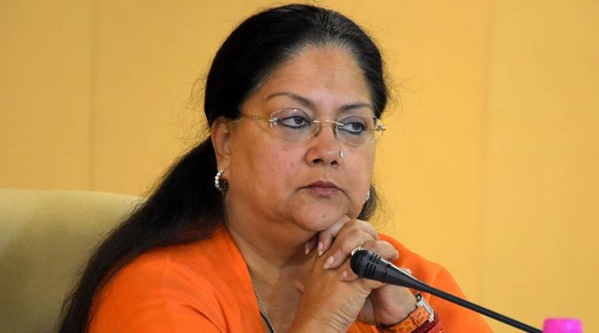
Rajasthan Chief Minister Vasundhara Raje (Express Photo by Rohit Jain Paras) , 2 September , 2016
The Rajasthan Assembly today unanimously ratified the Constitution Amendment Bill on Goods and Services Tax (GST) passed by Parliament. Speaking on the resolution, Chief Minister Vasundhara Raje said that the GST will have a very positive impact and states including Rajasthan will get advantages.
After the discussion the bill was unanimously ratified by the assembly on the second day of the session which began yesterday. Opposition members kept raising slogans against the cow deaths in Hingaunia gaushala during the debate on the GST.
After the ratification of the GST bill, the Speaker adjourned the House sine die. The Constitution (122nd Amendment) Bill, 2014 on GST was passed by Parliament recently and it needs to be ratified by at least 15 state legislatures before the President can notify the GST Council which will decide the new tax rate and other issues.
Yesterday Odisha Assembly had ratified the GST Bill. Odisha was the 16th state to ratify it.
The government has set April 1, 2017 as target for rolling out GST, considered the biggest tax reform in the country.

Puducherry ratifies GST Bill amid Opposition protest

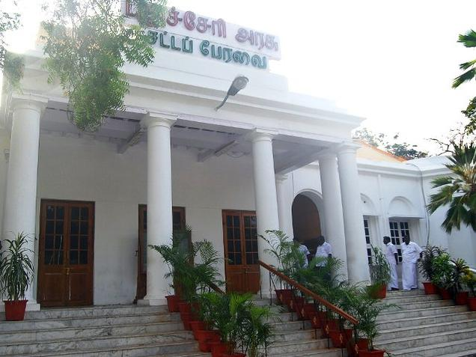

A view of the Puducherry Assembly.

"We have taken care that the GST Bill does not inflict any hardship on Puducherry," Mr. Narayanaswamy said.
The Puducherry Assembly on Friday ratified the Goods and Service Tax (GST) Constitution Amendment Bill amid a walkout by AIADMK members and continuing boycott by opposition AINRC.
The House adopted a resolution tabled by Chief Minister V. Narayanasamy for ratification of the bill, seen as the single biggest tax reform in decades. He asserted that steps had been taken to ensure that the new tax regime did not affect the Union Territory.
The bill, passed by Parliament, needs to be ratified by at least 15 state legislatures.
As Mr. Narayanasamy tabled the resolution, the AIADMK’s legislature party leader A Anbalagan raised apprehensions that the GST Act would be “injurious” to the Union Territory.
He also said the government should have given time to the members before bringing in the resolution and led the walkout by four members of AIADMK.
All the eight members of opposition AINRC were also not present as they boycotted the Assembly proceedings since Wednesday last.
Earlier, Mr. Narayanasamy, leading the Congress government, said he had at a meeting of the Empowered Committee of all State Finance Ministers on GST, made out a strong case to protect the interests of Puducherry and Union Finance Minister Arun Jaitley had assured to take care of it.
He said Puducherry government would continue to have its right to levy service tax and also tax on liquor.
“We have taken care that the GST Bill does not inflict any hardship on Puducherry,” Mr. Narayanaswamy said.
After the Chief Minister’s reply, Speaker V. Vaithilingam announced that the resolution was passed “unanimously”.

Disclaimer : The news in the GST Corner is purely according to the information available in public domain and does not necessarily reflect the views of ICSI. Any person wishing to act on the basis of this document should do so only after cross checking with the original source.

