GST HEADLINES
November 4, 2016

GST Council Fixes 4-Rate Structure: All You Need To Know About the 'Extremely Complex' Tax Reform

[Source: Firstpost]

GST Rates to Pull Down Inflation: FinMin

[Source: Business Standard]

Goa Government to Convene Special Session on GST

[Source: The Indian Express]

GST Council Fixes 4-Rate Structure: All You Need To Know About the 'Extremely Complex' Tax Reform

The country moved one step ahead in realising the GST dream as the GST Council on Thursday decided to fix a four-tier rate structure for the reform touted to be the biggest reform after the economic liberalisation of 1991.
While the structure and decisions taken have been welcomes by a section of the industry and experts, there are also criticisms.
Here are the key facts to know about the decisions taken on Thursday:
What are the key decisions taken?
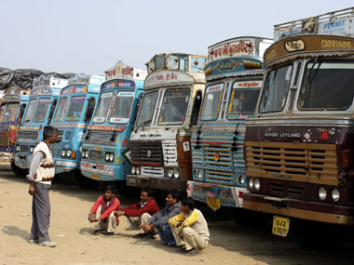
Reuters
1) The four bands of tax rates have been fixed at 5 percent, 12 percent, 18 percent and 28 percent. This apart, another category of tax between 40 percent and 65 percent will be imposed on luxury goods like high-end cars, pan masala, aerated drinks and tobacco products.
2) Food grains will be zero-rated to insulate people from inflationary pressures.
3) Most white goods, like washing machines, air conditioners, refrigerators, shampoo, shaving stuff and soap, will be taxed at 28 percent (with riders). The current levy varies between nil tax to 30-31 percent. The rider has been set as there are several items which are used by the lower middle class.
4) A decision has also been taken to levy a cess, in order to raise funds to compensate states for the revenue loss they incur. The government estimates Rs 50,000 crore will be needed in the first year for compensation. "If we have to raise this by way of tax, we will need Rs 1,72,000 crore," finance minister Arun Jaitley said.
However, he clarified that the cess, to be applicable on luxury cars, tobacco, aerated drinks etc, is not an additional levy, but an existing one and "there will not be an additional burden of even a rupee". A cess is not shared with the states.
5) So, demerit goods or sin goods, such as luxury cars, pan masala, aerated drinks, and tobacco and tobacco products, will invite a tax of 28 percent plus the cess. The overall incidence with cess, thus, could vary between 40 per cent and 65 per cent.
6) There has been no consensus yet on tax rate for gold.
What is the industry reaction?
India Inc has largely welcomed the rate structure. However, they are also worried that the multi-tier tax system may make the regime highly complex. It also suggested that most of the consumer goods should fall in the 18 per cent tax slab.
"Model GST Law suggests multiple registrations in each state for supply of goods and services. This has the potential to result in huge burden of complexity," said Naushad Forbes, President, Confederation of Indian Industry (CII). Forbes wants the government to eventually converge to one or two rates.
Federation of Indian Chambers of Commerce and Industry President has complimented the GST Council for arriving at a consensus and finalising the four-tier rate structure under GST.
However, it is not yet clear how the industry will fair.
Sharing quote from Harishanker Subramaniam, National Leader - Indirect Tax, EY India.
“The classification in different rate baskets is what will determine how sectors will fair under GST in comparison with the existing regime,” says Harishanker Subramaniam, national leader - indirect tax, EY India.
Will the rate structure increase inflation?
Too early to say. The reason is it is not yet known what all items will fall in each tax bracket. It is for the Committee of Secretaries to decide that. This is what the industry is also keenly awaiting.
As India Ratings and Research Chief Economist Devendra Kumar Pant says, "The impact of GST on inflation and different sectors of the economy can be evaluated only after the committee of secretaries decides on GST rates for different products."
However, presenting its proposal for a 6-26 percent four-tier rate structure at the earlier GST Council meeting, the Centre had estimated the inflation impact as follows: The overall impact on the consumer price index (-) 0.6 percent. The break up: on health services 0.56 percent; fuel and lighting 0.05 percent; clothing 0.23 percent; transport (-) 0.65 percent; education (-) 0.08 percent; housing (-) 0.09 percent.
Given the increase in the higher slab in the rate structure approved, some of these estimates are likely to change. Nonetheless, this could be a reference point.
MS Mani, Senior Director, Deloitte Haskins & Sells LLP says the categorisation of goods in these slabs has to be accomplished quickly.
"It is also necessary to ensure that majority of manufactured products are kept at 18 % and the temptation to push more products into the 28% slab should be resisted," he says.
According to him, decision on which products will fall in which category has to done considering present usage patterns. "This is due to the fact that products viewed as non essentials or luxury in the past are in many cases viewed as necessities now," he said.
What are experts saying?
Most of the tax experts have welcomed the earlier-than-expected resolution to the most contentious issue with GST.
Prashant Deshpande, Partner, Deloitte Haskins & Sells LLP, said the four-rate structure is on expected lines.
"The increase in maximum marginal rates to 28 percent coupled with the announcement that it will attract items which are currently taxed at rates in that range would mean that rate as a criterion would cease to play a role in evaluating benefits from GST for such products," he said.
It would be interesting to know what the government deems as common use items that fall in 5 percent bracket, he says.
As far as the consumer essentials and other products are concerned, the first reaction to the slabs is a thumbs up, says Anil Talreja, Partner, Deloitte.

GST Rates to Pull Down Inflation: FinMin

CEA says the Council has taken decision to bring down rate from 6% to 5% and move few products from 26% to 28% but many go from 26% to 18%
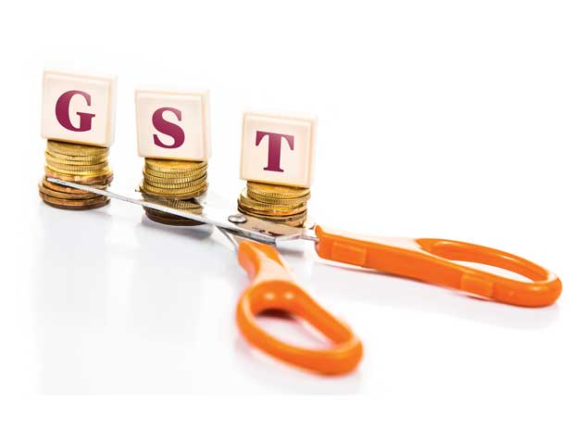
The finance ministry on Thursday said that the Goods and Services Tax (GST) Council's decision to impose five per cent tax on essential items would bring down inflation and levying a cess on luxury and sin goods over the peak rate would not burden the central kitty for compensation to states.

Chief Economic Adviser Arvind Subramanian said the Council's decision "should bring prices down. I don't think there is any fear on inflation because six per cent goes to five per cent. A few products move from 26 to 28 per cent but many go from 26 per cent to 18 per cent. On average this should probably serve to lower inflation."

If at all, the impact on inflation will be very small, he said. "Today's change should probably bring it down." He added the mood at the GST Council meeting was "very good" and the rate structure was unanimously decided.

Finance Secretary Ashok Lavasa said: "Now, you have a system by which additional burden of compensating the states is not being passed to consumers in a way it would have otherwise passed in terms of taxes. So, this is a very reasonable arrangement that has been agreed to, keeping in view the interest of the consumer and state governments." It also enables the central government to set apart a fund by which states will be compensated, he said.

About Rs 50,000 crore will be needed to compensate states for the loss of revenue from the roll-out of GST, which is to subsume a host of central and state taxes such as excise duty, service tax and value added tax, in the financial year beginning April 1.

The previous GST Council meeting headed by Finance Minister Arun Jaitley reached a consensus on the way states are to be compensated for any loss of revenue from implementation of the new indirect tax regime from April 1, 2017.

The base year for calculating the revenue of a state will be 2015-16 and secular growth rate of 14 per cent will be taken for calculating the likely revenue of each state in the first five years of implementation of GST. States getting lower revenue than this will be compensated by the Centre fully for the first five years.

Goa Government to Convene Special Session on GST

A four-tier GST tax structure of 5, 12, 18 and 28 per cent that aims to lower tax incidence on most goods and keep out essential items was decided by a high-powered council in Delhi on Thursday.
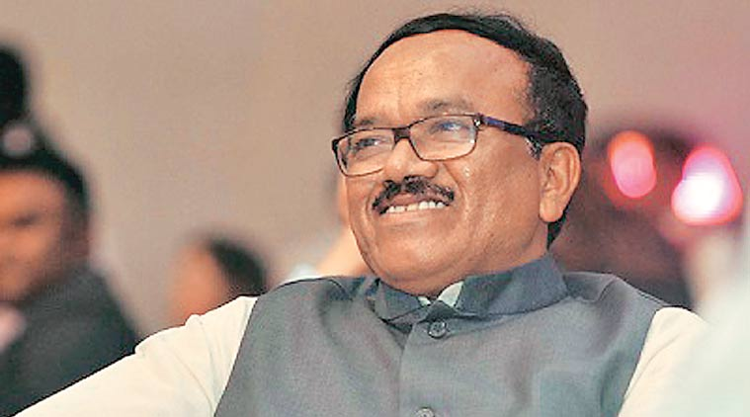
Goa Chief Minister Laxmikant Parsekar. (File Photo)
Goa government has decided to convene a special Assembly Session to discuss the GST rate, Chief Minister Laxmikant Parsekar said. “We have to call an Assembly Session to discuss the likely GST rates. It will be a one-day session. I am waiting for the Centre to finish their business over the GST,” Parsekar told reporters on Thursday. He said if not for GST, the session will have to be called to pass financial business like supplementary demands for grants and appropriation bill.
“I am not in a hurry to convene the session. We can call it even next month in December,” the Chief Minister said.
A four-tier GST tax structure of 5, 12, 18 and 28 per cent that aims to lower tax incidence on most goods and keep out essential items was decided by a high-powered council in Delhi on Thursday, a major breakthrough for rollout of the Goods and Services Tax (GST) regime from April 1 next year.
Responding to a query on the demand for special status for Goa, Parsekar said state government will not raise the issue before Prime Minister Narendra Modi during his visit to Goa on November 13, when he will come to lay the foundation stone of Mopa airport.
“BJP has a special focus on Goa. Although the state did not ask for it, we were given an opportunity to host the BRICS summit,” Parsekar said.
He also pointed out that Goa was given special attention when Modi chose Manohar Parrikar as the Defence Minister.
When pointed out that the special status was for protection of culture and identity, Parsekar said, “BJP will not allow even a scratch on culture and identity of the state.”

Disclaimer: The news in the GST Corner is purely according to the information available in public domain and does not necessarily reflect the views of ICSI. Any person wishing to act on the basis of this document should do so only after cross checking with the original source.

