GST HEADLINES
October 04, 2016

Service Tax Assessment under GST: Technical Committee to Iron out Differences, Hold Meetings

[Source : The Indian Express]

GST will Benefit India's Consumption Growth: Crisil

[Source : Business Standard]

A New Compensation Law to Re-assure the GST Law

[Source : Times News Service]

Service Tax Assessment under GST: Technical Committee to Iron out Differences, Hold Meetings

The team will then brief their respective state finance ministers, who are scheduled to gather in the national capital for the third GST Council meeting from October 18-21.

GST levy, area-based exemptions and draft rules dealing with registration, rules for payments, return, refund and invoices.

After differences cropped up between Centre and states regarding the administrative control of service tax assessees in the second meeting of GST council on Friday, a technical committee of officers will now hold a series of meetings, beginning with one later this week in Ahmedabad to resolve contentious issues. The team will then brief their respective state finance ministers, who are scheduled to gather in the national capital for the third GST Council meeting from October 18-21.
In its first meeting on September 23, the GST Council, which is headed by finance minister Arun Jaitley, had decided to allow states to have administrative control over Value Added Tax (VAT) assessees with annual turnover of less than Rs 1.5 crore and for turnover of over Rs 1.5 crore, a system of cross empowerment between states and Centre was agreed by the Council.
For around 11 lakh service tax assessees, a status quo was decided in the first meeting. The finance minister had conveyed that state government officials will be trained in due course to handle the service tax cases, but till then Centre will have exclusive jurisdictional control. It was also decided that new assessees which would be added to the list would be divided between the Centre and states.
The decision was later opposed by some states in the second meeting last week. Some states in the meeting proposed to have a cross empowerment model for top service tax assessees and exclusive control for Centre for smaller assessees. The top service tax assesees constitute over 30,000 out of total 11 lakh service tax assessees at present. Also, states have asked for more clarity regarding control of service tax assessees in sectors such as construction where both goods and services are involved, a senior government official said. Though the Council could have conducted voting on the issue, it was decided to refrain from going ahead with a vote and instead build a consensus among the states, the official added.
Due to this sticking point of service tax assessment between the Centre and the states, the minutes of meeting of the first GST Council meeting were not approved in the second meeting held on Friday.
“With regard to one item recorded in the minutes with regard to the service tax assessment in the new dispensation, there was a long discussion on the interpretation on the decision taken in the last meeting and that discussion consumed a lot of time today. That discussion was inconclusive and therefore it will continue in the next meeting on 18th (October),” finance minister Arun Jaitley told reporters after the second meeting on September 30.
The GST Council is trying to move swiftly to decide on issues of draft IGST, CGST and SGST laws and rules, GST rate structure and exemption lists by November 22 to meet its intended deadline of April 1, 2017 for the indirect tax regime. With two meetings, the Council has decided on threshold for
GST levy, area-based exemptions and draft rules dealing with registration, rules for payments, return, refund and invoices. The rules will be notified once the Act is passed and accordingly simultaneous changes are being made in model GST law. The GST Council has decided to fix the exemption limit for the indirect tax at Rs 10 lakh for northeastern states and hill states and Rs 20 lakh for other states along with decision to subsume all cesses into GST.
The next meeting of the council on October 18-20 will again take up discussions on service tax assessment and the formula for calculating compensation for states in case of revenue shortfall as a result of implementation of GST regime. The crucial issue of GST rate will also come up for discussion in the three-day meeting apart from selection of a state finance minister as the vice-chairman of the council.

GST will Benefit India's Consumption Growth: Crisil

From industry perspective, consumption related companies are expected to grow

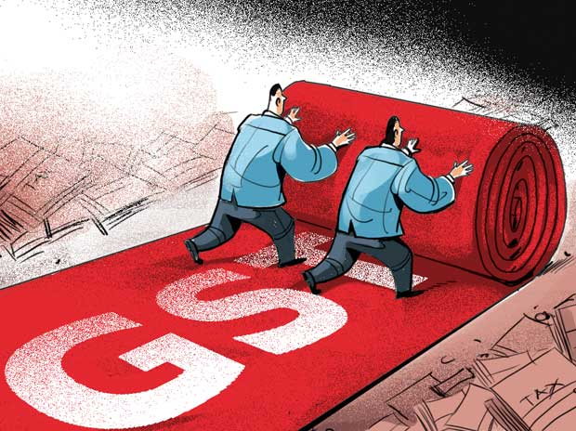
Ratings firm Crisil on Monday predicted a strong boost to India's domestic consumption in 2016-17 led by implementation of 7th pay panel's recommendations, with reforms like the Goods and Services Tax (GST) to benefit the uptick.
"Consumption growth will be buoyant in 2016-17. One Rank One Pension (OROP) and 7th Pay Commission will give a boost to domestic consumption this year and reforms like GST will further benefit India's consumption story," Pawan Agrawal, Chief Analytical Officer, Crisil said.
"So far this year we have seen India's story led by strong domestic consumption in auto-ancillaries, packaging and pharmaceutical sectors. What is noticeable is that we expect the rural demand to pick up in the second half of the current fiscal," Agrawal told reporters during a teleconference.
From industry perspective, consumption related companies are expected to grow. The growth will now be supplemented by rural India, he said.
For the remaining half of the financial year, he said the credit profile will further improve because of a healthy demand, improvement in liquidity profile and stabilisation of metal prices.
Also, the pace of implementation of reforms is a key factor in medium to long term that the rating agency will be monitoring, he said.
Crisil emphasised that sustainability will continue to be critical as there were hurdles like investment in infrastructure, slow transmission of Reserve Bank of India rate cuts from banks to customers that needed to be looked into.
"Weak demand still persisted in the real estate and construction sector. Banking sector too still seem to be bogged down by bad loans and for this fiscal, the level of non-performing assets will remain at elevated level," Agrawal said.
"Road sector is doing better, but it will take time for it to become visible. The global environment also remains uncertain," he said.

A New Compensation Law to Re-assure the GST Law

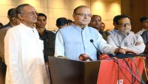
By Accommodation Times News Service

This legal ring fencing could help build consensus on GST rates when the issue is taken up next month, officials said
The government is likely to bring a separate law detailing the method of compensating states for any revenue loss from the goods and services tax to give a firm assurance to states that their revenues will be protected even if the GST rate is low.
This legal ring fencing could help build consensus on GST rates when the issue is taken up next month, officials said.
“Compensation mechanism will be given a legal backing,” said a senior government official confirming some deliberations on the issue. The formula has broadly been agreed to at the first meeting of GST Council yesterday and today and its nitty-gritty would be finalised before the next meeting by officials.
The constitution amendment to roll out GST provides for full compensation to the states for five years but there are no details mentioned. “Parliament shall, by law, on the recommendation of the Goods and Services Tax Council, provide for compensation to the States for loss of revenue arising on account of implementation of the goods and services tax for a period of five years,” the amended law says.
A separate compensation law is being mulled that will give the provisions a statutory framework. GST will replace all indirect taxes on goods and services levied by central and state governments.
States have in past complained of the Centre going back on its word on compensation for phase out of central sales tax and differences on the issue had hurt the progress on GST for some time. It was only after past dues were cleared that states agreed to move forward on the new tax regime.
The base year for GST compensation is fixed at FY16 but other details like what would be the percentage increase every year over the five year period are to be worked out.
A legally binding compensation agreement will give states comfort to support a lower rate of GST as they would be protected against any loss. The Central government is keen on a lower rate and lesser exemptions though states have pitched for GST rate of more than 20 per cent. A high GST rate would cause inflation.

Disclaimer : The news in the GST Corner is purely according to the information available in public domain and does not necessarily reflect the views of ICSI. Any person wishing to act on the basis of this document should do so only after cross checking with the original source.

