GST HEADLINES
November 02, 2016

Centre Moves to Overcome Hurdle on Dual Control of GST

[Source: Business Standard]

Assocham Urges against Cess, suggests GST Rate Hike by 1-2%

[Source: NDTV Profit]

Centre Moves to Overcome Hurdle on Dual Control of GST

The two-day meeting between the Centre and state finance ministers to discuss GST norms begins on Thursday
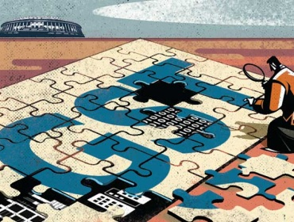
The sticky issue of administration or control over assessees under the goods and services tax (GST) regime is close to a breakthrough. The Centre is likely to propose that the power of audit and scrutiny should be with the Union as well as state governments without any threshold. The two-day meeting between the Centre and state finance ministers to discuss GST norms begins on Thursday.
The Centre, however, is likely to audit and scrutinize fewer assessees than states. The issue of administrative control is one of the key matters to be taken up by the GST Council on Thursday and Friday, after an earlier agreement between the Centre and states fell through in the last month meeting.
According to an earlier proposal, states were to assess businesses with an annual turnover Rs 1.5 crore, while both the Centre and states were to do so for businesses having higher turnover. The Centre and states had earlier agreed that the Centre will have exclusive power over assessees in the service sector, till the state officials were trained to do so. But some states raised objection to this.
“Threshold is a bad idea as turnover of a company keeps changing. Besides, it is difficult to have a clear distinction between what classifies as a good or service. So instead, we can have clear distinction to carry out audit and scrutiny. We are willing to carry out a lot less intervention than states. If states want the comfort of numbers, they will get that,” said a government official who did not wish to be identified.
There will be “cross-empowerment” right from the beginning to ensure that a taxpayer will have to deal with one authority for all taxes to protect them from harassment. Under the framework, both the Centre and states will have administrative control over assessment, scrutiny and audit for the central GST and state GST. Whoever strikes first will carry out the assessment for CGST, SGST and IGST.
“There will be a demarcation on who will carry out what audits. We want to supervise so that taxes grow and more people comply,” said the official. In case of scrutiny, if the states want to do it for 5-10 per cent cases, the Centre will do for just 1-2 per cent, as per the proposal. This will ensure that both Centre and states will share equal powers on all tax matters.
Which assessee would be assessed by which administration would be decided on the basis of risk assessment. The list will be shared with one another, based on which each authority will get its share of assessees for auditing and checking for a possible evasion. Only about 5 per cent entities will be audited under the GST regime.
PROPOSALS
- Two-day GST Council meeting begins on Thursday. Administrative control one of the key issues to be discussed
- Union govt is likely to propose that the power of audit and scrutiny be with both central and state administrations
- This would ensure Centre and states share equal powers on all tax matters
- Only about 5% entities would be scrutinized under the GST regime, of which Centre plans to audit only 1-2 %

Assocham Urges against Cess, suggests GST Rate Hike by 1-2%
The next meeting of the GST Council, chaired by Mr. Jaitley, is slated for November 3-4
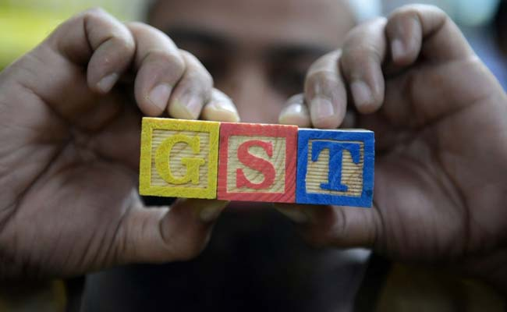
New Delhi: Arguing against the levy of cess, Assocham has written to Finance Minister Arun Jaitley to hike the proposed Goods and Services Tax by 1-2 per cent to compensate states for revenue loss under the GST system.
"The idea of levying cess to make a corpus for compensation to states does not seem to be feasible. The additional revenue required for such compensation can be collected by increasing the tax rates (by 1-2 percent) instead of levying the cess," Assocham Secretary General D.S. Rawat said in a letter written last week to Jaitley.
The next meeting of the GST Council, chaired by Mr. Jaitley, is slated for November 3-4.
On the crucial issue of the tax rate structure, which three earlier meetings of the GST Council failed to decide, Mr. Jaitley has said that a four-slab structure of 6, 12, 18 and 26 per cent is under consideration, with lower rates for essential commodities and higher ones for luxury goods.
It has been proposed that items constituting nearly 50 per cent of the weightage in the Consumer Price Index basket, mostly food items, be exempted from the levy.
Besides, a cess is also likely to be levied on demerit or sin goods and polluting items.
The industry body Assocham suggested that essential commodities of mass consumption like fruit, vegetables and grains should not be taxed, while processed food products like dairy products, rice, edible oil and biscuits should attract six per cent duty.
It said mobile phones, computers, fruit juices, pet foods should be taxed at 12 per cent and other items at 18 per cent.
Luxury cars, tobacco and pan masala should be taxed at 26 per cent, Assocham added.
Mr. Jaitley suggested last week that in order to compensate states for loss of revenue in the GST regime, a cess on tobacco and luxury goods is an option preferable over additional tax, which will be exorbitantly high.
"Assuming that the compensation is Rs 50,000 crore for the first year, the total tax impact of funding the compensation through a tax would be abnormally high. An Rs 1.72 lakh crore of tax will have to be imposed for the central government to get Rs 50,000 crore in order to fund the compensation," Mr. Jaitley wrote in a Facebook post.
"Fifty per cent of the tax collected will go to the states as their GST share and of the balance 50 per cent in the hands of the Centre, 42 per cent more will go to the states as devolution."
"So, out of every 100 rupees collected under the GST system, only 29 per cent remains with the Centre. The tax impact of this levy will be exorbitantly high and almost unbearable," he said.
"Different items used by different segments of society have to be taxed differently. Otherwise, the GST will be regressive. Air conditioners and hawai chappals (flip-flops) cannot be taxed at the same rate. Total tax eventually collected has to be revenue neutral. The government should not lose money necessary for expenditure nor make a windfall gain," he added.
Mr. Jaitley proposed, instead, imposing cess, which would be subsumed in the taxes after five years.
"This will include cess on clean energy, luxury items and tobacco products, which in any case presently also pay levy higher than 26 per cent. This will ensure no additional burden on the taxpayer and yet be able to compensate the losing states," he said.
The Finance Minister said if cess is levied, the states which benefit from the GST will not have to compensate the losing states.

Disclaimer: The news in the GST Corner is purely according to the information available in public domain and does not necessarily reflect the views of ICSI. Any person wishing to act on the basis of this document should do so only after cross checking with the original source.

