GST HEADLINES
January 02, 2017

GST Delayed, Rollout Now Likely on 1 June

[Source: Livemint]

GST Delayed, Rollout Now Likely on 1 June

Expectations are that the GST legislation will be now be introduced in the first half of the budget session of Parliament
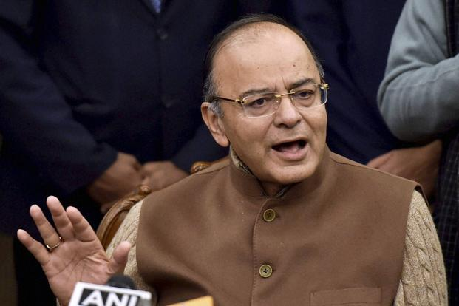
Finance minister Arun Jaitley is expected to announce the timetable for GST in his budget speech. Photo: PTI

The rollout of the goods and services tax (GST) is likely to be delayed by two or three months, according to two people familiar with the situation.
The government is yet to lock down a date, but is likely to settle for either 1 June or 1 July, the people said on condition of anonymity.
Expectations are that the GST legislation will be introduced in the first half of the budget session and the government will seek to get it passed after the recess.
While the new dates would delay the rollout, they are also well within the mandatory deadline of September—after which the central and state governments will lose powers to levy any indirect taxes other than GST.
Differences between the centre and the states, especially over the sharing of powers, has delayed the final approval for supporting legislations for GST, a tax reform which will for the first time bind the country into a common market.
States like Kerala and West Bengal had sought a delay in the implementation of the tax, arguing that state finances cannot withstand the double whammy of demonetization and GST.
GST will subsume a host of indirect taxes levied by the centre and the states, including excise duty, service tax, value-added tax, entry tax, luxury tax and entertainment tax.
Though its implementation would have been easier from the beginning of a fiscal year, it can be implemented anytime. GST is an indirect tax levied at the point of sale and hence can be introduced at the beginning of any month.
Finance minister Arun Jaitley is expected to announce the timetable for this ambitious tax reform in his budget speech on 1 February.
The finance ministry will also have to work out its revenue estimates for 2017-18 based on GST’s implementation date.
All eyes will now be on the crucial 3-4 January meeting of the GST council in New Delhi that will discuss the contentious issue of sharing of administrative powers between the centre government and the state governments.
A consensus is imperative for the integrated GST bill that deals with the levy of GST on inter-state movement of goods to receive the council’s approval.
So far, after months of deliberation, the council has approved the draft central and state GST legislations, and has given its nod to the bill on the compensation of states for revenue losses arising from a transition to GST.
While the central GST bill, integrated GST bill and the bill on the compensation of states for revenue losses will be tabled in Parliament, the state GST bill has to be tabled in state assemblies.
“Since April 1 looks difficult, the government has little option but to bring in GST from any month next year. Since it is a transaction tax, it can be brought in at any time. However, the challenge will be to do a revenue forecast in the budget. It will be prone to huge errors,” said N.R. Bhanumurthy, a professor at the National Institute of Public Finance and Policy.

Disclaimer: The news in the GST Corner is purely according to the information available in public domain and does not necessarily reflect the views of ICSI. Any person wishing to act on the basis of this document should do so only after cross checking with the original source.

