GST HEADLINES
November 1, 2016

Call To Reclassify Coir Products Under GST

[Source :Business Line ]

GST Network To Borrow Rs 800 Cr From Banks To Fund GST Infra Building Cost

[Source :Business Standard ]

Call to reclassify coir products under GST
COIMBATORE, OCTOBER 31:
The proposed GST tax regime could adversely impact the coir industry, particularly manufacturers of coir mattresses, if coir and rubberised coir mattresses and sheets are not classified under the merit or essential list, say industry insiders.
Appealing to the Centre to classify such coir products under essential list or low tax bracket under the proposed GST regime, S Sundaresan, President, All India Coir Mattress Manufacturers’ Association, said both coir and rubber latex used in the manufacture of rubberised coir mattresses are natural products, eco-friendly and bio-degradable.
Such coir mattresses are predominantly made out of coir, an agro product. The sector is in line with the ‘Make in India’ scheme with a majority of inputs being sourced locally from unorganised sectors.
Coir mattress manufacturers face stiff competition from those that use PU (Polyutherine) foam as substitute for coir. The foam is invariably imported, he said. The Ministry of Finance at present provides various fiscal incentives to the manufacturers and exporters of coir products. For coir mattresses, a concessional levy of excise duty at 2 per cent (without CENVAT credit) or 6 per cent (with CENVAT credit) is being extended.
States charge nil or lower VAT rate of 5 per cent on coir products. VAT levy however varies from 5 per cent to 15.5 per cent on various coir mattresses as against 13.5 per cent to 15.5 per cent on foam-based mattresses.
“From information in the public domain, we understand that the Government is considering to tax environment unfriendly products “distinctly” from others in the GST regime. Consequently, classifying coir-based products under concessional category when compared to alternative products to promote their usage would result in penalising the polluting products and incentivising green products,” Sundaresan said, appealing for reclassifying coir products under merit list.

GST Network to borrow Rs 800 cr from banks to fund GST infra building cost

Of this, Rs 250 cr is towards working capital and Rs 550 cr is long-term
2
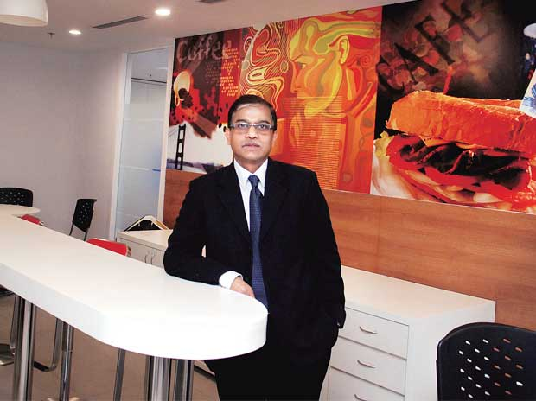
File photo of GSTN’s Chief Executive Officer Prakash Kumar at a ‘breakout room’ at the company’s new headquarters at Worldmark I in the Aerocity complex

GSTN, the company that is building the world's biggest and most complex tax system, will borrow Rs 800 crore from banks to fund infrastructure costs to support Goods and Services Tax rollout from April 1 next year.
The Goods and Services Tax Network (GSTN), a not-for-profit, non-government, private limited company promoted by the central and state governments, is borrowing Rs 250 crore for working capital needs and another Rs 550 crore as long-term loan from domestic lenders, its chairman Navin Kumar told PTI here.
The government of India has 24.5 per cent stake in GSTNand the state government an equal share. The remaining 51 per cent is with private financial institutions.
"The total authorised and paid-up capital is Rs 10 crore. So, Rs 4.90 crore has come from central and state governments and Rs 5.10 crore from private institutions," he said.
Kumar said the cost of infrastructure to support the GSTwill be Rs 1,380 crore.
"We will be borrowing Rs 550 crore for infrastructure. We have also sought some working capitallimit, that we will see if there is any default in payment," he said.
Since its incorporation on March 28, 2013, the GSTN had used Rs 64 crore towards payments to its vendors and employees out of the central government's sanctioned grant of Rs 315 crore for the first three years.
"Government has released Rs 120 crore from the grant, and we have used Rs 64 crore, rest of the money we have to refund to the government," he said, adding this year entire expenses would be met through borrowing.
Kumar said after receiving Letter of Guarantee from the government, the GSTN will raise a five-year term loan of Rs 550 crore from various Indian banks.
"We have also requested for a Rs 250-crore working capital loan. So, if there is any delay by any government in making payment, then we will borrow money. We have selected the banks," he said.
Explaining how the working capital and term loan would work, he said working capital loan works like a credit and at the end of the year the borrower has to square up the loans. But the payment of term loan has to be made every month.
GSTN is a non-government, private limited company promoted by the central and state governments with the specific mandate to build the IT infrastructure and the services required for implementing Goods and Services Tax (GST).

Disclaimer : The news in the GST Corner is purely according to the information available in public domain and does not necessarily reflect the views of ICSI. Any person wishing to act on the basis of this document should do so only after cross checking with the original source.

